(Approx. 1012 words)

Casting, not in the theatrical sense – Cast your data to the screen
By Phil Sorrentino, Newsletter Contributor, Sarasota Technology Users Group
March 2021 issue, STUG Monitor
www.thestug.org
philsorr (at) yahoo.com

Most modern computers have HDMI outputs so it is easy to display your computer screen on a big-screen TV, but what about displaying your smartphone screen on that same big screen? Most phones do not have HDMI or more specifically micro-HDMI connectors. (Though I have seen some tablets with micro-HDMI connectors, in fact, I even had one that I used for teaching a smartphone/tablet class.) So, you have to find another way to get the smartphone screen displayed on the larger TV screen. Fortunately, Google has provided a solution with its Chromecast hardware device and Casting software that is becoming part of many Apps. (If your App supports Chromecast, you will see the Chromecast icon somewhere on the App’s opening screen). The Chromecast device gets plugged into an HDMI input port on the big screen TV, and power is provided to the device by a micro-USB connection. A Chromecast device and an App that supports casting can turn a dumb TV into a pretty smart TV, at least for those Apps that support casting.

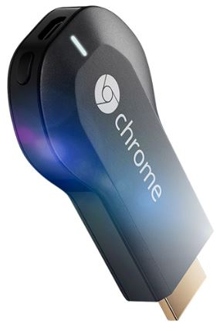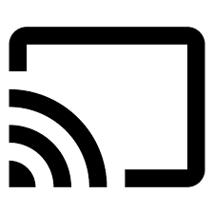
Chromecast Device Chromecast Icon

Besides the Chromecast device, the only other thing you need is Wi-Fi. Wi-Fi is the mechanism used to transfer the smartphone screen information to the Chromecast device which in turn provides the HDMI interface to the big screen TV. So, to make it work, both the smartphone and the Chromecast device have to be on the same Wi-Fi network. Many current Wi-Fi routers provide many networks. Usually, the main network is in the 2.4 GHz frequency band and there may be another network in the 5 GHz band. The 5 GHz network sometimes includes 5G in the network name which can possibly be confused with the 5G wide area network provided by companies like Verizon and AT&T. (Future Wi-Fi routers can even take advantage of a new 6 MHz band.) Also, some routers may provide a guest network in the 2.4 GHz or 5 GHz band. The trick here is to make sure that when you set up the Chromecast device you choose the same network that your smartphone is using. You can see what network your smartphone is using by going into Settings on the smartphone and selecting “Network & internet” or “Wireless”, or something like that, where the network name will be shown. This is usually early in the list of settings. (When you select this screen, you will also see the other networks that are available but are not currently being used by your smartphone.)

Once you know the Wi-Fi network you will be using you can set up the Chromecast device. This will be done using your smartphone and usually the Google Home App.

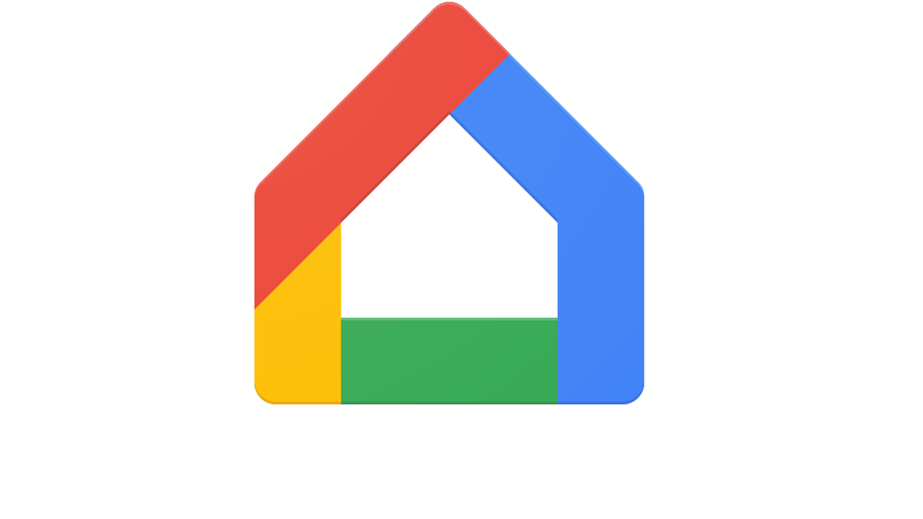
Google Home App Icon

You can download the Google Home App from the Google Play Store or the Apple App Store. Apps are updated regularly and screens may change so specific directions for this setup may be different by the time you need them but when you do need directions, Google something like “How to set up a Chromecast device using the Google Home app”. The results will probably be several tutorials or even better a few videos with up-to-date instructions. (The Google Home App provides control for many devices besides the Chromecast. Home automation lights, cameras, and switches are also set up using this App. Additionally, this App also provides control for Google’s “Google Home” assistant.) Once you have set up the Chromecast device you can cast your smartphone screen to your big screen TV. (And to see what else you can do with the Home App, just find the “Discover” icon which looks like two sheets of paper. This is really an advertisement for all the wonderful things Google can do for you once you have their products.) As well as Google Home their other Apps that can be used to set up the Chromecast device and that support Casting, such as LoCast for Chromecast, iMediashare, Cast to TV, Mirroring360 Sender, and Plex but I have not tried any of these.

With the Chromecast device setup, all we need to do is find Apps that can Cast. Some of the more popular Apps are YouTube, YouTube Music, Google Photos, Disney+, Prime Video, Hulu, Media Monkey, Movies Anywhere, Netflix, Crackle, Pluto TV, Tubi, Hoopla, and HBO Max. There are even a lot of Apps that appear to be cable channels like A&E, History, AMC, MTV, and TNT. Many more Apps may have this ability in the future. You may already have some of these apps on your smartphone like YouTube, but the other Apps are available at the Google Play Store or the Apple App Store. Once you’ve downloaded the App of interest, look for the Cast icon somewhere on the opening screen.

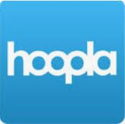

Hoopla App

Hoopla is an App supports casting. This means that you can now take advantage of all the video media at your local library; videos, TV shows, and feature-length movies. You can use your phone to access the media and then cast the media to your Chromecast device plugged into any TV that has an HDMI input. Using Wi-Fi to cast the media means you are also using Wi-Fi to access the media from the library, so there is no cost associated with the whole process. You can think of that as free movies for the whole family, at least if the big screen TV is big enough to satisfy the whole family. All you have to do is supply the popcorn. By the way, as was discussed in a previous article in September, Hoopla can also bring you E-books to read, audiobooks to listen to, and even music to listen to. What a bargain. If you haven’t gotten the Hoopla App yet, go to the Google Play Store, or the Apple App Store and download it and start taking advantage of this very useful, and did I mention, free App.

